Brand Guide — Section 9

Team & Collaborators

Lee Entertainment is built on talent, trust, and a shared commitment to excellence. Every person in this section plays a meaningful role in delivering the Lee Entertainment experience — from the lead DJ who designs the client journey, to the collaborators who bring additional dimensions to any celebration.

This section serves as the official reference for all team members and creative partners. It is a living document — new collaborators will be added as the Lee Entertainment family grows.

The Founder

DJ Abe Lee

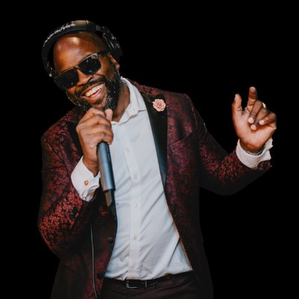 | DJ Abe Lee  Abraham Lee  Founder & Lead DJ
DJ Abe Lee is the Founder and Lead DJ of Lee Entertainment — a Vancouver Island entertainment company built on the belief that great events don't happen by accident. They're designed.
Originally from Jamaica and now rooted on Vancouver Island, Abe brings a global musical perspective to every performance. His style blends classic and modern sounds across genres, reading the room in real time, guiding the energy, and keeping dance floors full while ensuring every key moment flows exactly as it should.
With a deep passion for both music and people, Abe approaches every event as more than a party — it's a carefully curated experience built around each client's vision. He is known for his calm presence, clear communication, and ability to collaborate seamlessly with planners, venues, and vendor teams from ceremony to last song.
But Lee Entertainment is more than a DJ company. Abe founded it with a broader purpose: to create a platform where emerging DJs can learn the craft, build their own businesses, and grow together. His goal is to help others help themselves — developing a team where everyone succeeds.
At the heart of everything is a simple commitment: serve people well, and create moments that will be remembered for a lifetime.

DJ Collaborators

The DJ Roster
Lee Entertainment works with a select group of DJ collaborators who share the same standards of professionalism, versatility, and client care. Each collaborator is carefully chosen and fully vetted before joining the roster.

DJ Dfresh Musik
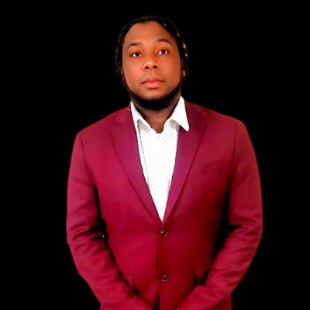 | DJ Dfresh Musik  Daley Albert  DJ Collaborator — Open Format Specialist
DJ Dfresh Musik grew up in the lush hills of St. Elizabeth, Jamaica — immersed in the legendary sound system culture of the island from an early age. Those early days feeling the bass of local street dances planted the seeds for what would become a globe-spanning musical journey.
Since migrating to Canada in 2007, Dfresh has steadily climbed the ranks of the North American music scene — sharpening his craft in Toronto's competitive DJ culture, expanding into the promotional world in Calgary, and now establishing himself as a premier force on Vancouver Island and the BC Mainland.
What sets Dfresh apart is his Open Format mastery. He moves effortlessly between Reggae, Afrobeats, Hip-Hop, R&B, EDM, Country, and Top 40 — a versatility that has made him a high-demand professional for elite weddings, corporate galas, and nightclub residencies alike.
His resume speaks for itself — Dfresh has shared the stage and opened for international artists including Nelly, Sean Kingston, Serani, Charly Black, and Hypasounds. Beyond the decks, he brings his own professional-grade sound system to every booking, ensuring the sonic quality always matches the performance.

DJ SUAR3Z
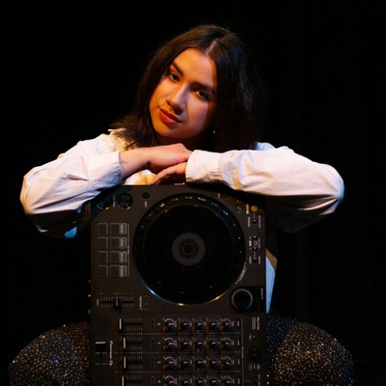 | DJ SUAR3Z  Katherine Pineda  DJ Collaborator — DJ & Live Vocalist
DJ SUAR3Z grew up in a musically rich household with family roots in Colombia — surrounded by rhythm, melody, and culture where no genre was off limits. Music became both her passion and her language from the very beginning.
Before stepping behind the decks, Katherine began her journey as a vocalist, performing jazz and soul across Vancouver Island. That foundation in live performance and musical storytelling naturally shaped her approach as a DJ — where she blends genres seamlessly and creates sets that feel like a journey from country to country, all without leaving the dance floor.
DJ SUAR3Z performs at clubs, private events, and weddings throughout British Columbia, bringing versatility, professionalism, and vibrant energy to every celebration. What makes her truly unique within the Lee Entertainment roster is the rare combination of DJ and live vocalist — able to sing you down the aisle and keep your dance floor packed with your favourite tracks.
Her goal is simple: to celebrate your event exactly the way you envisioned it, with moments that feel personal, intentional, and full of life.

Band Collaborators

Live Music Partners
For events where live music elevates the experience, Lee Entertainment partners with talented musicians who share our commitment to quality, professionalism, and unforgettable moments. Live music collaborators work seamlessly alongside our DJ services to deliver a complete entertainment solution.

Julia & Laurence
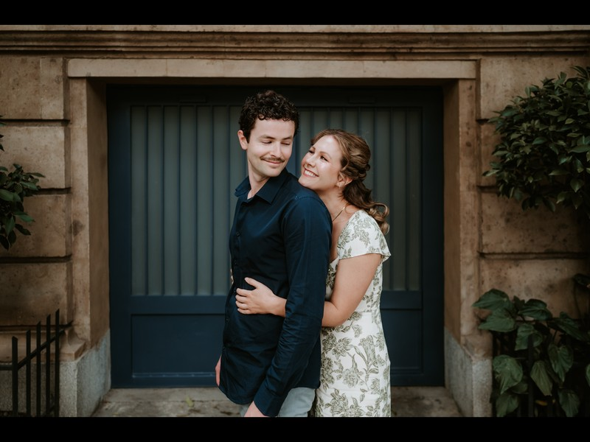
Julia & Laurence
Acoustic Duo & Live Band — Ceremony, Cocktail Hour & Reception
Julia & Laurence bring a warm, inviting presence to every event — creating an atmosphere that feels both elegant and heartfelt. Featuring rich vocal harmonies paired with guitar and piano, their sound adds depth and emotion to ceremonies, cocktail hours, and dinner settings. Music that enhances every moment without ever overpowering it.
With years of experience performing together as an acoustic duo — alongside extensive individual backgrounds as live musicians — their chemistry and musical intuition allow them to shape the tone of each moment with care and intention.
For couples and clients looking to elevate the energy, the addition of a drummer transforms the duo into a dynamic three-piece band, ideal for lively receptions and dance-focused celebrations. With a repertoire spanning timeless classics to contemporary pop, Julia & Laurence seamlessly adapt to the vision of each event — delivering a soundtrack that feels personal, polished, and unforgettable.

Growing the Roster

Join the Lee Entertainment Team

Lee Entertainment was built to grow — and to bring others with it.
If you are a DJ, musician, or creative professional who shares our values of excellence, professionalism, and genuine care for clients — we would love to hear from you.
Contact Abe directly: abraham@leeentertainment.ca • 250-884-0536

Lee Entertainment • Vancouver Island, BC, Canada
leeentertainment.ca • abraham@leeentertainment.ca • 250-884-0536
Brand Guide — Section 9: Team & Collaborators

